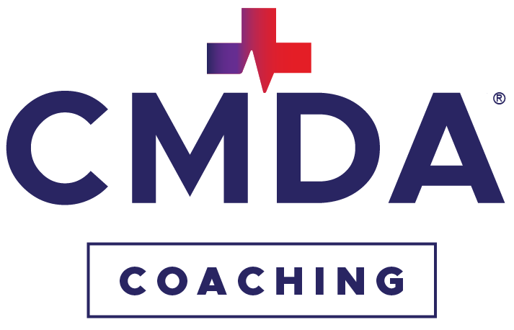
When Helping Isn’t Working
How to Help People Really Change

Healthcare professionals are trained to diagnose, advise and solve problems.


Those are essential skills. However, there are numerous conversations—in the clinic, at home, in leadership, mentoring, discipleship and teamwork—where people don't primarily need more answers.

They need someone who will listen well enough to help them discover their own.

That’s what coaching does.

Coaching doesn’t replace the expertise you’ve worked so hard to develop. It adds another way to help people grow and change when advice alone isn’t enough.

10 Ways a Coaching Mindset Changes Your Conversations—and Your Impact

1 Recognize Your “Fix-It” Mode
You might recognize yourself if you often...
- Jump quickly to giving advice  - Feel responsible for solving everyone’s problems  - Become frustrated when people don’t follow your recommendations | - Carry the emotional weight of other people’s decisions  - Find yourself talking more than listening  - Wonder why your best advice isn’t always helpful
If so...
You're in good company.
Healthcare professionals are trained to fix!
2 Understand Why We Default to Fixing
The fixing mindset feels natural because:
- We’ve spent years becoming experts  - People expect answers from us | - Solving problems is rewarding  - We genuinely want to help
The problem isn’t fixing.
It’s fixing when listening and empowering would be more effective.
Several of our most important conversations involve problems that can't simply be solved by our expertise alone, things like behavior change, leadership, relationships, burnout, motivation, calling, conflict and personal growth.
Those conversations often require a different approach.

3 Make the Shift to a Coach Approach
Instead of... |  | Try...
Fixing | → | Empowering
Telling | → | Asking
Directing | → | Exploring
Giving answers | → | Drawing out insight
Owning the problem | → | Helping others take ownership
Being the expert | → | Becoming a thinking partner

4 Know When a Shift to Coaching Could Be Better
Expert advice is invaluable.
However, there are times when people are more likely to move forward after they’ve clarified their own motivations, uncovered their own barriers and chosen their own next step.
Learning when to teach or advise and when to coach makes us more effective in both roles.

5 Why This Matters
When we rely only on fixing... | When we use a coaching approach...
Relationships can become strained | Relationships grow stronger
People become dependent | People take ownership
Motivation decreases | Motivation increases
Creativity is limited | Better solutions emerge
Patients may be less likely to follow through | Sustainable change becomes more likely

6 A Coaching Mindset Is Grounded in Scripture
“Let every person be quick to hear, slow to speak....”
—James 1:19b, ESV
“If one gives an answer before he hears, it is his folly and shame.”
—Proverbs 18:13, ESV
Listening deeply isn’t passive.
It’s one of the most practical ways we love people well.

7 Coaching Changes You
One of the greatest surprises of learning to coach is that it transforms not only the people you serve but also the way you experience your own work and relationships. Many healthcare professionals discover:

- Less stress from feeling responsible to fix everyone  - Better relationships at work and at home  - Stronger listening skills | - Greater joy in healthcare and ministry  - Healthier personal and professional boundaries  - Greater effectiveness as a leader

8 It Can Improve Any Conversation
Whether you’re caring for patients, leading a team, mentoring a colleague, discipling someone in your church or talking with your family or friends, coaching skills help you create conversations marked by greater trust, curiosity, ownership and growth.

9 You Don’t Have to Stop Being the Expert
Healthcare professionals should continue using their knowledge, training and experience generously.
Coaching simply gives you another tool—one that helps you recognize when your greatest contribution is not another answer but a listening ear or a thoughtful question.

10 Learning to Coach Will Strengthen You Spiritually
- Helps you see and draw out the Imago Dei in others
- Requires humility
- Fosters dependance on God in the moment to listen and ask powerful questions
- Grows your own self-awareness

Ready to Learn More?

CMDA’s 501 Foundations for Coaching course is a highly engaging course tailored to Christian healthcare professionals that will equip you with the mindset, and practical skills to get started coaching in a variety of settings. This continuing education-qualified course also gives you credits toward becoming a professional certified coach if you decide to pursue that route. Find out more and register for the next cohort starting September 29 at https://cmda.org/life-leadership-coaching/courses/.

Questions? Email coaching@cmda.org.

CMDA Coaching - Professional One-on-one Coaching for Christian Healthcare Professionals and Coaching Training – cmda.org/coaching

